http://cdn.garcya.us/wp-content/uploads/2011/01/garcya.us_abstractwallpapers4713-140x140.jpg

http://www.sunhome.ru/UsersGallery/wallpapers/29/19163148.jpg

http://www.smashingmagazine.com/wp-content/uploads/2010/01/warrior_21.jpg

7сл
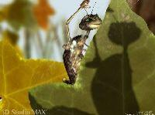http://www.compdoc.ru/grafics/3d/bases3dmax/BugShower_sm.jpg

http://i.dailymail.co.uk/i/pix/2008/12/15/article-1095043-02CFBB40000005DC-613_468x364.jpg
8сл
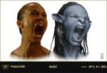http://geektyrant.com/storage/post-images/Patton-Saldana-Avatar-Concept.jpg?__SQUARESPACE_CACHEVERSION=1262656109634

сл2
http://www.mariapikalova.ru/content/illustration/autumn.jpg

http://scr.templates.com/screenshots/illustrations/vector-illustration-of-a-flat-monitor-with-the-image-of-a-wall-leaves-and-a-snail-on-it.1100.1137.jpg

http://img1.liveinternet.ru/images/attach/c/2/66/502/66502430_f_495a717c14ab6.jpg

3сл
http://pvpsiddhartha.acm.org/acm/images/photoshop.jpg

4сл
http://www.post-art.ru/files/%D0%9E%D0%B1%D1%80%D0%B0%D0%B1%D0%BE%D1%82%D0%BA%D0%B0%20%D1%84%D0%BE%D1%82%D0%BE%D0%B3%D1%80%D0%B0%D1%84%D0%B8%D0%B9/foto9.JPG

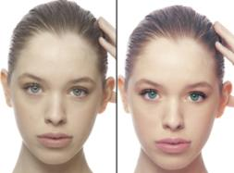http://www.freelancerbay.com/files/users/ankudinova/portfolio/5031_%D0%BF%D0%B0%D0%BE%D0%B0%D0%B8-1.jpg
5сл.
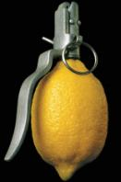http://g.mynet.com/i/197/44711_0.jpg

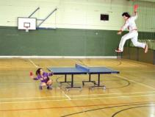http://rnns.ru/uploads/posts/2009-11/1257752046_222.jpeg

http://img15.nnm.ru/f/f/7/a/d/4132adcccfe62c74c5f9fdc3e0c_prev.jpg

6 слайд
http://www.kakprosto.ru/sites/kakprosto/files/styles/step_full/public/images3/201112/step-742aba4efa853dc8bf6c2531117543df.JPG

http://www.rebzi.ru/UserFiles/festival/1bf8e8453a.jpg

7 слайд
http://us.123rf.com/400wm/400/400/alinoubigh/alinoubigh0903/alinoubigh090300262/4503081-3d-illustration-microphone-for-modern-music.jpg

